ROBOT USED IN VISION THERAPY FOR KIDS

*ABSTRACT*

Following with the previous work which we have done in the Final Research Project, we introduced a therapeutic

application with social robotics to improve the detection of vision problems on kid. Different works about therapeutic

robotics, positive psychology, emotional intelligence, social learning and mood induction procedures (MIPs) are reviewed.

Hardware and software requirements and system development are explained with detail. Conclusions about the clinical utility

of these robots are disputed.

Keywords: therapeutic robotics; social learning; human-robot interaction; vision therapy.

# CONTENTS

[**CONTENTS**](#_myjtdvtupsxa) **0**

[**INTRODUCTION**](#_5cw5ozabuvr4) **1**

[Children & Vision Therapy](#_kcc6kwie554o) 1

[What Is Vision Therapy or Vision Training?](#_vennipbue6p4) 1

[**1 BACKGROUND**](#_lp9c59m7ev90) **2**

[1.1 Therapeutic robotics](#_vb9f0mm5nfpc) 2

[1.2 The expression of emotions](#_y27dszs2f35q) 3

[1.3 Social Learning](#_c39mr1dgjlvu) 4

[1.3.1 Social learning in human-robot interaction](#_u3ejyg9fkez6) 5

[1.4 Vision Therapy and the autistic child](#_yey5ey41f78f) 5

[This is about more than 20/20 eyesight. This is about being able to effectively take in and process visual information. If your child falls within the autism spectrum and demonstrates some of the following visually associated behavioral characteristics, vision therapy can make a profound difference.](#_otkn7mxyaxek) 6

[**2 DEVELOPMENT**](#_dboi6ue93a45) **6**

[2.1 Requirements](#_qbawintybq8) 7

[2.2 Hardware](#_nd683n3q9wrq) 7

[2.3 Software](#_uw715ulzkgpf) 9

[2.3.1 NAO speech](#_zct9g0n6j504) 11

[2.3.2 NAO motion](#_xo7inlmqoob5) 11

[2.3.3 Speech recognition](#_9yivr8w0033w) 14

[2.3.4 Positive mood](#_7vfm2mn8vjjm) 14

[2.3.5 The vision training application](#_4kqpnqmr8x33) 15

[2.3.5.1 Technology (Naoqi + HTML5)](#_vy28rfsrd5bl) 15

[2.3.5.2 The training application](#_k2cctz4g8494) 15

[2.3.5.3 Features](#_171z3fgxkwfe) 15

[2.3.5.4 The training exercises:](#_en6psnx28vs6) 16

[**3 EXPERIMENTS**](#_yjl8zjqim90c) **16**

[3.1 EXPERIMENTS ABOUT THE SYSTEM PERFORMANCE](#_6jikm34iayf3) 16

[3.1.1 BEHAVIOURS](#_wzlvi5bso2rd) 16

[**4 ANNEX I: Mindfulness session**](#_xuegshilltfm) **17**

[**5 CONCLUSIONS**](#_koacc4z8jr2f) **17**

# INTRODUCTION

## Children & Vision Therapy

Vision problems in children, other than simple refractive errors such as nearsightedness, farsightedness and astigmatism are not uncommon. Vision problems such as eye alignment, amblyopia (“lazy eye”) or focusing problems, eye teaming problems and visual perceptual disorders require vision therapy. Left untreated, these non-refractive vision problems can cause learning problems, fatigue, eyestrain and headaches.

## What Is Vision Therapy or Vision Training?

**What is vision therapy?** “Vision therapy is a series of activities that helps develop visual skills so you can use your eyes efficiently and easy.”

**What tests determine if you need vision therapy?** “We are optometrists…we are going to do tests based on what a person does with their eyes…For kids having trouble with school, we’re going to look at the quality of their eye movements.”

**Do all optometrists practice vision therapy?** “Every optometrist is trained in vision therapy…but not every optometrist does vision therapy.”

Vision Training or Vision Therapy also called orthoptics is an individualized program for the treatment of non-refractive vision problems. Eye exercises and tasks are tailored to the child’s specific vision problem. The therapy can be performed in an optometrist’s office with additional visual tasks that the child will need to perform daily at home.

Behavioral optometrists or developmental optometrists are optometrists who specialize in vision therapy and the treatment of learning-related vision problems.

According to these, the principal aims of this work are:

* Implementation of an advanced and affective behaviors and positive emotions system in the NAO robot that helps to lift some kids with learning and attention issues while using vision therapy or training.
* Implementation of a human-robot feedback system.

The background on which this project is based are first described in Chapter 1, which explains a brief overview about the basics of positive psychology and emotional intelligence, therapeutic robotics, mood induction, social learning and vision therapy in autistic child.

In Chapter 2, the project requirements are showed. Furthermore, how these requirements have been achieved with the hardware and software development are described.

Chapter 3 describes the experiments which have been done to test the performance of the system.

Finally, the conclusions obtained are highlighted and the future lines are mentioned.

# 1 BACKGROUND

## 1.1 Therapeutic robotics

It has been demonstrated in so many cases the benefits of the therapeutic use of robotics. Therapeutic robots are social robots that are used to care people with behavioral, emotional or motor disorders, as well as chronic disease or are used in rehabilitation therapies. As social robots, they must follow the human social behaviors rules established to interact and communicate with others.

In recent years, the robot NAO has also begun to be used as a therapeutic robot to improve the social interaction in children with autistic syndrome disorders (ASD). A social robot must be able to communicate and interact with people and other agents with a physical structure, called embodied agents. The communication can be through verbal and non-verbal language. Verbal language can be expressed through writing or orally through speech. Non-verbal language can be expressed through gestures and movements. Since this robot is able to perform a lot of movement and it can talk, it has the essential features to communicate with others.

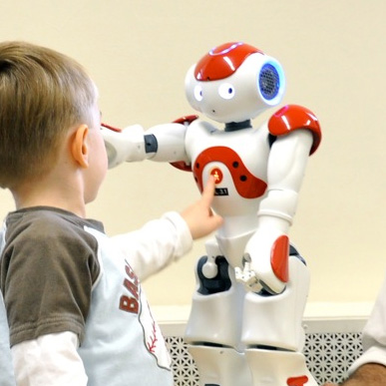

Figure 2. Robot NAO interacting with an ASD child

## 1.2 The expression of emotions

The ability to express a feeling is an essential social skill. Learning this deployment of roles takes place at a very early age. One of them is to minimize the emotions in the presence of an authority figure. Another is to exaggerate one feeling magnifying emotional expression, like children complain to his mother. A third is to replace a feeling for another (something that usually takes place, for example, in those Eastern cultures in where say ‘no’ is considered rude and instead, false positive emotions are expressed).

Empathy is the ability to tune emotionally with others. The key that allows us to access to the emotions of others is the ability to capture the non-verbal messages (tone of voice, gestures, facial expression, etc.). A survey of 1,011 children showed that those who were better able to read non-verbal emotional messages had a greater emotional stability. Unlike the rational mind, which is communicated through the words, the emotions do it non-verbally.

However, extremes never are so good. On one hand, one should keep in mind that excessive empathy can be harmful. The overflow perceived negative emotions, the feeling of inadequacy and not knowing self-regulate these emotions and feelings can cause what is known as empathic suffering. On the other hand, there are some people who are unable to perceive the feelings of others. These persons have alexithymia.

**Empathy in human-robot interaction**

It is possible to build robots that appear to show empathy, which is commonly understood as the capacity to “put your-self in someone else’s shoes to understand his/her emotions.” Empathy research indicates that it is made possible by a special group of nerve cells called mirror neurons, at various locations inside the brain. Mirror neuron activity helps people understand actions and intentions of others and is also involved in understanding emotions. Empathy may be facilitated through a process of automatic mapping between self and other. Perception of the actions and emotions of others activates areas in our own brain that typically respond when we experience those same actions and emotions. Here, based on the Plutchik’s theory of emotions, eight types of basic emotions are created by setting angles of the joints of the robot NAO.

## 1.3 Social Learning

In accordance with Albert Bandura social learning theory assumes that modeling influences produce learning principally through their informative functions and that observers acquire mainly symbolic representations of modeled activities rather than specific stimulus-response associations. In this formulation, modeling phenomena are governed by four interrelated sub processes:

* Attentional processes. A person cannot learn much by observation if he does not attend to, or recognize, the essential features of the model´s behavior.
* Retention processes. A person cannot be much influenced by observation of a model's behavior if he has no memory of it.
* Motoric reproduction processes. The third component of modeling is concerned with processes whereby symbolic representations guide overt actions. To achieve behavioral reproduction, a learner must put together a given set of responses according to the modeled patterns. The amount of observational learning that a person can exhibit behaviorally depends on whether or not he has acquired the component skills. If he possesses the constituent elements, he can easily integrate them to produce new patterns of behavior, but if the response components are lacking, behavioral reproduction will be faulty. Given extensive deficits, the sub skills required for complex performances must first be developed by modeling and practice.
* The modeling process and transmission of response information. A major function of modeling stimuli is to transmit information to observers on how to organize component responses into new patterns of behavior. This response information can be conveyed through physical demonstrations, through pictorial representation or through verbal description. Much social learning occurs on the basis of casual or studied observation of exemplary models.

### 1.3.1 Social learning in human-robot interaction

In human-robot interaction the most social learning method used is the teacher-learner. The learner uses the teacher as a model. A simple imitative strategy is used as the social bonding mechanism.

One of the oldest works (1999) that are done. This article addresses embodied social interaction in lifelike agents. ‘Dancing with strangers’ experiment shows how the same principles can be applied to physical robot-human interaction. The AURORA project for children with autism which addresses issues of both human and robotic social agents is introduced. This work is based on the following working hypotheses:

1. Life and intelligence only develops inside a body.
2. Which is adapted to the environment which the agent is living in.
3. Intelligence can only be studied with a complete system, embedded and coupled to its environment.
4. Intelligence is linked to a social context. All intelligent agents are social beings.
5. There is no memory but the process of remembering.
6. Memories do not consist of static items which are stored and retrieved but they result out of a construction process.
7. The body is the point of reference for all remembering events.

The long-term goals of the AURORA project are twofold: 1) helping children with autism in making the initial steps to bond with the (social) world, 2) studying general issues of human-robot interface design with the human-in-the loop, in particular a) the dynamics of the perception-action loop in embodied systems, with respect to both the robot and the human, b) the role of verbal and non-verbal communication in making ‘social’ interactions, c) the process of adaptation.

The conclusions are that scaling up from simple imitative behaviors like pre-programmed following (learning by imitation) towards 1) more complex forms of imitation and imitating robots, 2) learning to imitate is possible. And that it is better that robots can have the role of a ‘social mediator’ instead of replacing humans.

## 1.4 Vision Therapy and the autistic child

Children with autism frequently suffer from functional vision problems and those vision problems are often overlooked.

### This is about more than 20/20 eyesight. This is about being able to effectively take in and process visual information. If your child falls within the autism spectrum and demonstrates some of the following visually associated behavioral characteristics, vision therapy can make a profound difference.

* Poor eye contact
* Staring at lights or spinning objects
* Side viewing and looking through or beyond objects
* Light sensitivity
* Atypical reactions to visual stimuli
* General difficulties attending

While commonly associated with Autism Spectrum Disorders (ASD), these behaviors are often symptoms of visual dysfunctions. An vision therapy program can help with these symptoms.

The ramifications of visual dysfunction can also lead to poor eye-hand coordination, issues with fine and gross motor skills, impulsivity, poor spatial awareness, and reduced depth perception.

Vision therapy helps to treat sensory issues and retrain the brain.

**Parents have reported improvements in:**

* Better eye contact
* Visual motor skills
* Body coordination
* Social interaction
* Body awareness and balance
* Interest in reading and looking at books

# 2 DEVELOPMENT

To make the system affordable for its use by therapists, we have selected for our application a medium-sized humanoid robot, such as Aldebaran Nao. Furthermore, we think that its beautiful appearance, soft movements and the way it talks represent an advantage over other existing humanoids. Therefore, the main aim of this work is to implement an emotive system that allows the robot NAO to participate in a therapy lifting positive moods. In particular, NAO will develop the role as a co-therapist in a part of a psychologist session to increment and improve the positive moods with people who have fibromyalgia. Additionally, it must have a feedback system that allows the communication between the therapist and it.

NAO will present a mindfulness session when the therapist directed it and will guide children doing the principal instructions.

For more information about the mindfulness session please refer to Annex I.

## 2.1 Requirements

Based on our hypothesis, the system was primarily designed to be applied in optical shop or clinic (Vision Care Optical Service). In this way, to complete gratefully the mindfulness session as a co-therapist, NAO must be able to:

* Speak in an understandable and comprehensive way.
* Move according the things it is saying or it is hearing in the webview application.
* Recognize the patient and the therapist instructions.
* All these previous requirements must be based in the positive psychology, the emotional intelligence, mood induction procedures, social learning, and the human-robot interaction principles.

For more information about the movements NAO must realize and the instructions it must recognize, please refer to Annex I.

## 2.2 Hardware

The humanoid robot NAO is used in this project. A detailed description of it can be viewed in the web page: http://www.aldebaran.com/en

The NAO hardware devices used for this proposition are highlighted in the figure below:

|  |  |
| --- | --- |
| aldebaran-robotics-nao-h25-humanoid-robot-academic-4-large_large.jpg  Figure 2. NAO hardware | * Chest Button: to turn on and turn off the robot pressing it during 3-5 seconds approximately. * Front, rear and lateral microphones: to collect sound information, such as speech. * Speakers: to reproduce speech. * LEDs: to emit color lights. * Tactile sensors: to manage the parts of the narrative. * Motors: to move the joints forming different poses. |

*NOTE: microphones place must be noticed for give the instructions to NAO. The best distance is approximately 0.8m (usable range: 0.2 – 2.5m).*

There are three tactile sensors in the head that allows different functions.

|  |  |  |  |  |  |  |  |  |  |  |  |  |  |
| --- | --- | --- | --- | --- | --- | --- | --- | --- | --- | --- | --- | --- | --- |
| tactile_head_114.png  Figure 3. Tactile sensors of the head | Table 2. Sensors functions   |  |  |  | | --- | --- | --- | | **Sensor name** | **Type** | **Function** | | A | Front | Start the session. Restart a part. | | B | Middel | Stop a part | | C | Rear | End a part |   *NOTE: before restarting a part, please stop it* |

The motors allow the movement of the joints to form different poses controlling their motion speed and position.

|  |
| --- |
| hardware_motortype_h25.png  Figure 4. Motor joints |

## 2.3 Software

**Python** is one of the programming language supported by NAO. Because of this language is the code that is below the main software tool of NAO,

**Choregraphe**, we decided use it to develop the main program.

**NAOqi** is the name of the main software that runs on the robot and controls it. The NAOqi Framework is the programming framework used to program NAO.

The NAOqi executable which runs on the robot is a broker. When it starts, it loads a preferences file called autoload.ini that defines which libraries it should load. Each library contains one or more modules that use the broker to advertise their methods.

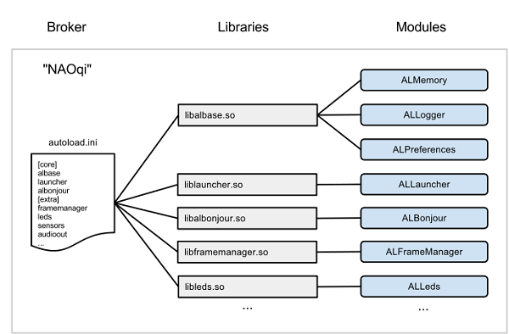

Figure 5. NAOqi Framework

The broker provides lookup services so that any module in the tree or across the network can find any method that has been advertised.

Loading modules forms a tree of methods attached to modules, and modules attached to a broker.

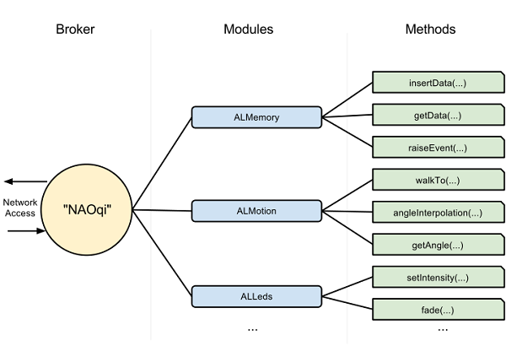

Figure 6. NAOqi libraries

Typically each Module is a class within a library. When the library is loaded from the autoload.ini, it will automatically instantiate the module class. Each module contains various methods.

### 2.3.1 NAO speech

To speak in an understandable and comprehensive way the text to speech library has been used as the principal module. It allows write the words you want NAO says. Changing the speed and the pitch parameters of the speech a natural oral communication is achieved.

### 2.3.2 NAO motion

The key point here is to use body language in this context as the principal means to induce mood. To move according the things NAO is saying or it is hearing in the webview application a synchronized audio movement method is needed.

The different positive poses and movements and the rhythm of the speech or the webview application is achieved through the timeline pane of the Choregraphe application. It also allows to synchronize them. The Timeline panel is displayed when you double-click on a Timeline box.

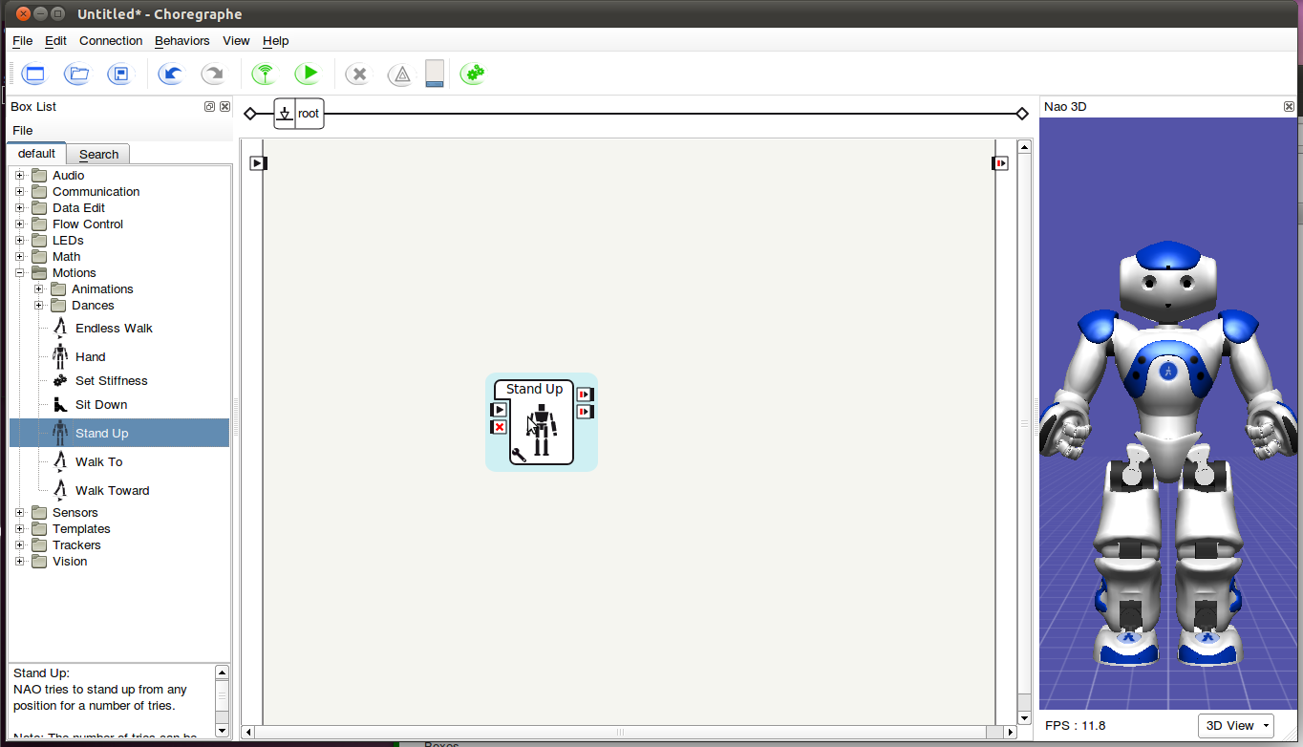

Figure 7. Timeline panel

It enables you to edit the Timeline of the box.

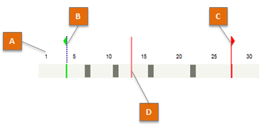

Figure 8. Timeline of the box

A Timeline enables you to easily synchronize boxes with movements, movements with each other and/or boxes with each other. It is constituted by:

* A Motion layer which contains movements.
* Optionally one or several behavior layers which contain flow diagrams NAO will execute in addition to its movements.

The whole Timeline is based on a time ruler. The time is represented on the Timeline by numbered Frames. Each Frame corresponds to a position of the robot and/or Flow diagrams to execute. The speed to move from a Frame to another is defined by the Frame rate of the Timeline.

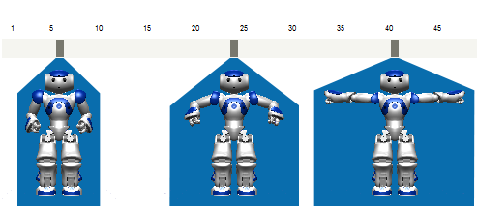

Figure 9. Postures in three different points of the timeline box

Each body position can be done modifying the position of each joint selecting the correspondence part of the body in the simulated robot which appear in the timeline panel.

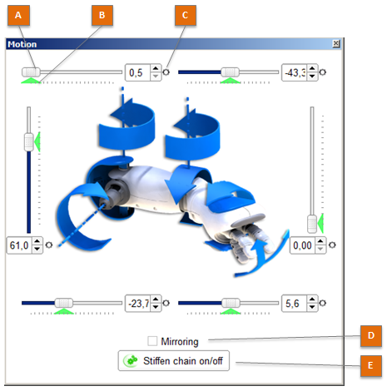

Figure 10. Creating a posture with the simulated robot.

Another possibility to create a new posture is manipulating and recording the position of the joints in the real robot. Both methods store joints positions in the key frame selected. You can select to record whole body or different parts of the body (head, arms and/or legs).

### 2.3.3 Speech recognition

Speech recognition is used here because the robot requires manages the dialogue with the therapist.

There is a module in NAOqi that allows the speech recognition. Although theoretically it can recognize any word, in practice, there are a lot of words that it does not recognize very well. This module is done fundamentally to discriminate some words or short sentences of a concrete list to select a choice between different options. Both were supposed a problem to develop an adequate way to recognize the main instructions the therapist tells to NAO. On one hand, it is very difficult to NAO discriminates words when a continue speech is doing. Some words are very similar and this can confuse the recognition process. On the other hand, the recognition process changes depend on the distance between the person who is speaking and the robot. These two difficulties have been resolved in a practical way, with so many trial and error tries.

### 2.3.4 Positive mood

Positive mood can be expressed with positive corporal language implemented in the robot.

Table 3. Words of ANEW which appear in the therapeutic narrative of the mindfulness session

|  |  |  |
| --- | --- | --- |
| **Part of of body** | **Position** | **Meaning** |
| Head / body | Erect | Pride, joy |
| Body | Sitting and facing squarely to other children | Social stance |
| Arms | Raised and tilted slightly backward | Happiness, surprise, pride |
| Arms | Open, above the shoulders and head | Happiness, success, surprise |
| Arms | Stretched out frontal or upward | Elated joy |
| Arms | Crossed in front of chess | Happiness. |
| Arms | Uncrossed and opened | Open social posture |
| Shoulders | Lifted | Elated joy |
| Forearms | Rotated outwards | Social stance |
| Elbows | Extended or slightly bent | Joy |
| Hands | Hand (s) in the heart (left breast) | Need to emphasize their truthful position |

Speed, pitch and volume of the voice contribute to transmit the speech information in a positive way too.

### 2.3.5 The webview - Vision training application

#### 2.3.5.1 Technology (Naoqi + HTML5)

In order to implement a communication between NAO Robot and the therapy or training application:

[QiMessaging](http://doc.aldebaran.com/2-4/dev/js/index-1.0.html#js-1-0) of Naoqi framework provides JavaScript bindings to use QiMessaging services (modules) in a web browser. It allows you to build HTML5 applications for NAO robot.

The library was designed to be asynchronous. Most function calls return a Deferred object, as specified by [jQuery](http://api.jquery.com/deferred.promise/), but [reimplemented](https://github.com/warpdesign/deferred-js/) to avoid shipping the whole library. [Socket.IO](http://socket.io/) is used to provide bidirectional communication between the robot and the browser.

#### 2.3.5.2 The training application

Between the ages 3 to 8, it is the perfect time for treatment of vision problems. After this golden period, nerves in the eye begin to mature, and correction thereafter becomes increasingly difficult. That’s why if there’s a history of severe nearsightedness or astigmatism, it’s best to bring your children to a physician to check his/her eyesight as soon as possible.

Correction of eye problems usually involves tedious and repetitive coordinative exercise, such as navigating a maze on paper, drawing lines on paper, etc. The blandness of such exercises is the primary reason that children become resentful or even express refusal to cooperate in the treatment!

The App turns vision correctional exercises into fun and interesting games, assisting them with fascinating themes like robots and planet, enticing the children to perform the necessary occlusion for the training and ultimately making real correctional progress.

Recovery of vision does not happen overnight, nor is there a shortcut. This is precisely why active participation of those who need it is vital.

#### 2.3.5.3 Features

1. Must be a cooperations with doctors experienced in treatment of vision problems specifically designed to help improve patient vision.
2. Makes training into fun and interesting games, increasing willingness to participate in correction.
3. Records the daily performed exercises and correctional results, providing a better picture for physicians and parents for assessment of progress.
4. Puts training results into easily to view charts.
5. Includes some categories of training, with enriched content that kids won’t get tired of easily.

#### 2.3.5.4 The training exercises:

1. Rotating grating. Vision is stimulated by looking at objects through gratings of different thickness and spacing.
2. Color-Light training. The various colors and shades stimulate the visual nerves.
3. Eyeball muscle exercise. The frequent change of focal point gives eyeball muscles a workout.
4. Hidden object recognition. Eyes get trained to recognize specific objects in a visually distractive background.
5. Color sensitivity training. The recognition of a specific color from a selection of similarly shaded colors is trained.

# 3 EXPERIMENTS

### 3.1 EXPERIMENTS ABOUT THE SYSTEM PERFORMANCE

The mindfulness session has three main parts. The first, when the therapist presents NAO and it introduces the main aspects of the application and launches it. The second, when the application is running and the robot moves according to the instructions of the application. And the third, in which the robot waves off. Each part has been tested in different ways described in the following sections.

More information is provided in Annex I.

### 3.1.1 BEHAVIOURS

The behaviours have been developed in Choregraphe. Each part of the mindfulness session has a behavior developed here. All the parts must allow start it, stop it, and finish it because an unexpected problem could happen during the session. That is why all the parts contain the tactile head box to manage these possibilities.

#### 3.1.1.1 The Steps

1. Therapeutic as Nao about play a vision game.

1. The robot welcomes the user to the game and introduce the vision training game. The robot tell the child “The goal is to count the number of times that the red robot appears on the screen, Please keep your attention and eyes on the screen”. The process send the media presentation to the screen (described in the webview application section ), and waits for the response and reacts accordingly.
2. When animation ends, the robots ask child “How many red robots have shown on the screen?”
3. The child responds.
4. The robot check the response. Success: Congrats or Fail: keep more attention the next time. The robot goes to game again.

### 3.1.2 WEBVIEW APPLICATION

Show a presentation in order to explain the robot's question (in this case don't use touch feedback from the webview).

The webview is manage from the robot in order to show messaging or interactive vision games training using events or signals. And allow patient to play training exercises, send feedback touch events and transfer the game score to the robot.

# 4 ANNEX I: Mindfulness session

Develop an experiment to proof the bi-directional communication protocol between the webview application and the robot.

## 4.1 THERAPEUTIC STORY

### Part 1

The exercise begins with child patient sitting in the chair. The therapist asks the patient if is ready and comfortable. Then the robot is presented by the therapist:

**Therapist:** “Today we are going to have a special help. I present you to NAO who will be my co-therapist today.”

**Therapist:** “Nao help me to make a fun game. Thank you so much NAO.”

NAO recognizes (the start event), Then, it answers and presents the mindfulness vision training game.

### Part 2

The session is playing and the webview application is on:

**NAO:** “Welcome to the vision training game exercise one”

**NAO:** “Press my front head sensor to skip instructions. I'm going to ask you a question. Please respond after the beep, when I will be listening. Tap with your palm all of my head sensors to exit this game.”

Four robots are showing on the game. Orange, green, blue and red.

**NAO**: “What robot do you prefer? Orange, green?, blue?, red?

**Child:** Child choose one of them. Orange!

**NAO:** “The goal is to count the number of times the red robot appears on the screen, Please keep your eyes on the screen”

The child patient sees launching the application in the webview with a presentation describing the NAO´s question.

The animation of the screen ends.

**NAO**: “How many @color robot have shown on the screen?”

**Child patient:** “Six”

**NAO:** ”You'll probably win next time!”

The webview presentation is removed.

**NAO:** ”Do you want to play again?”

**Child patient:** “Yes”

**NAO:** “Please, can you count how many @color robots can you see in the screen?”

The child patient sees launching the application showed on the webview with a presentation.

The animation of the screen ends.

**NAO**: “How many @color robots have shown on the screen?”

**Child patient:** “Eleven”

**NAO:** “Very good!”

**NAO:** ”Do you want to play again?”

**Child patient:** “No”

**NAO:** “Congratulations!”

NAO close the application.

### Part 3

After the exercise the Therapist gives thanks to the child patient and NAO

**Therapist:** “Thanks you %name-child”

**Therapist:** “Thanks you NAO.”

Finally goodbye to everyone.

# 5 CONCLUSIONS

By drawing on evidence from positive psychology and mood induction, my goal was to develop a system that generate interest, attraction and induce positive emotions with a humanoid robot that is affordable to be used by therapists on a regular basis.

According to the previous sections, one of the best methods to to attract the child's attention is the expressiveness, sounds and gestures of the robot.

On the other hand, human-robot interaction is mainly based on human social interaction. I know the teacher-learner method is the most popular social learning procedure in human-robot interaction, which is based on imitation.

Consequently, the main goal of this project is to find out how a humanoid robot can express positive emotions through body language and catch the attention of the children but without facial expressions, since our target implementation is a commercially available and affordable humanoid, such as NAO, that can easily be used by therapists.

A mood induction tool to motivate and transmit positive emotions to children patients with or without fibromyalgia in order to progress in a cognitive vision therapy process.

### 